Employee:

Log in screen will show.

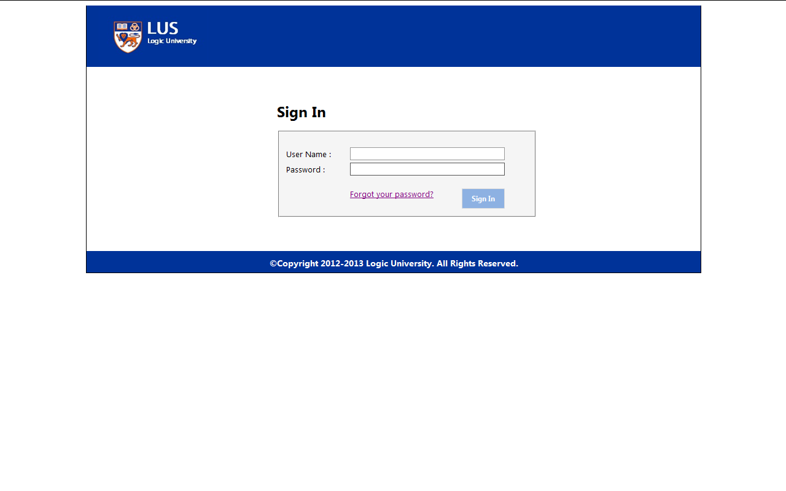

After input username and password and click ”Sign In”, if username and password are wrong, system will show “Login failed”.

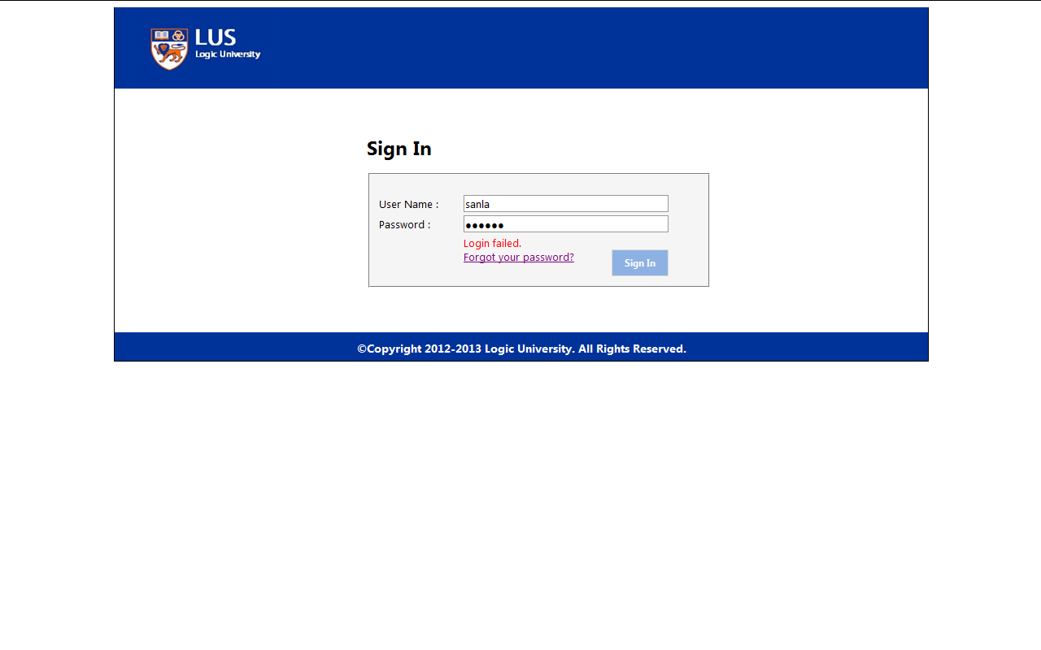

After input username and password and click ”Sign In”, if username and password are correct, employee default screen will show.

(Screen)

If employee forgot password, after input username, click “Forgot your password”.

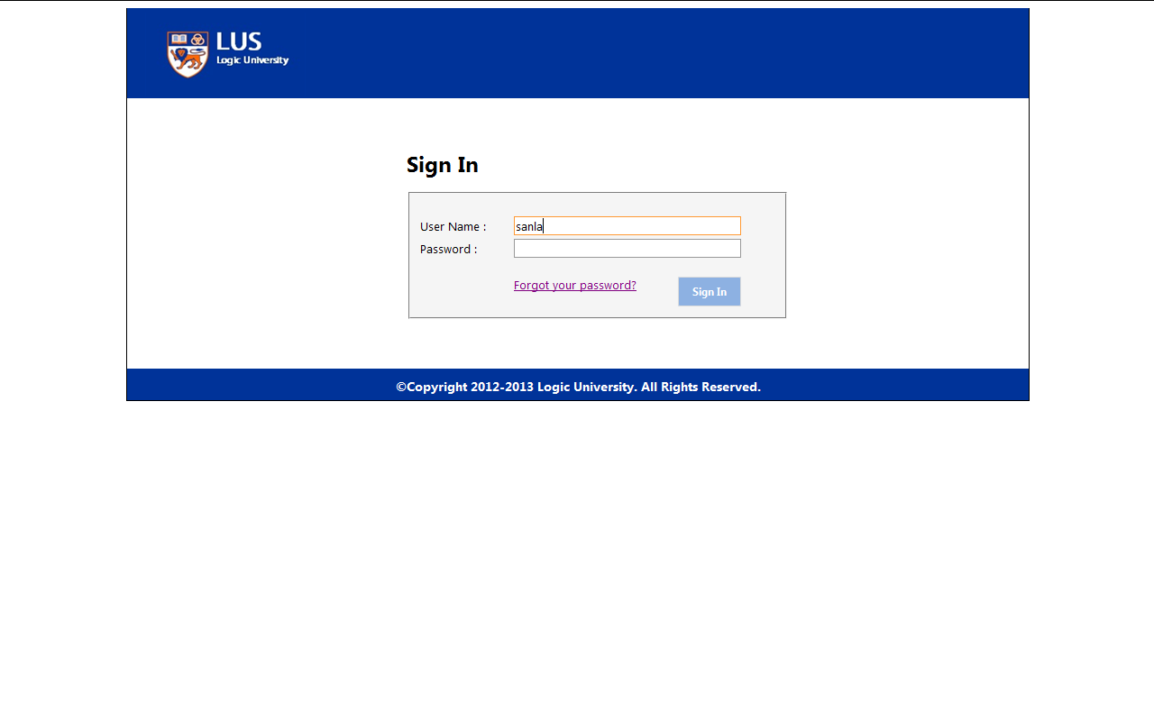

Input email address and click “Send”, system will automatically send email, then you can get password.

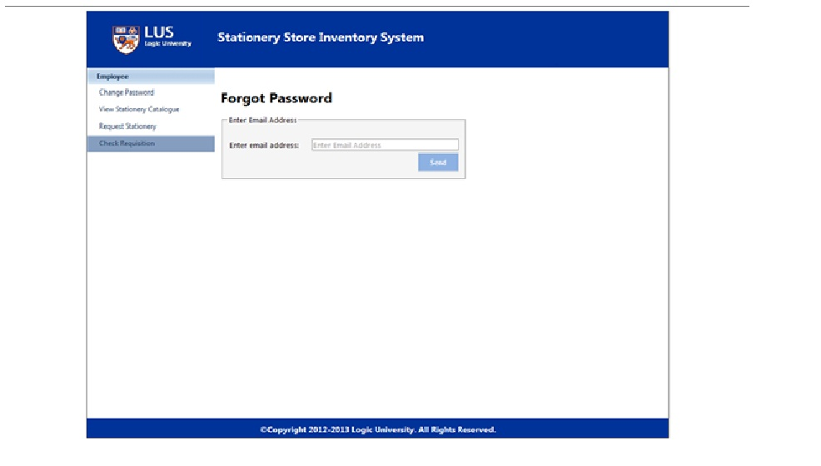

Change Password

Click “Change Password” link from menu, change password will show.

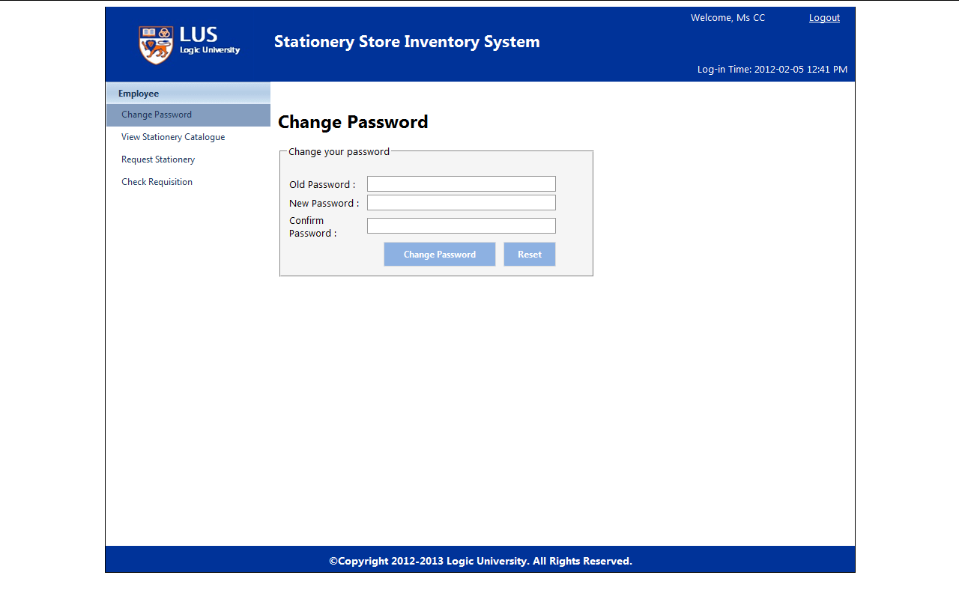

Input old password, new password and confirm password, click “Change Password”.

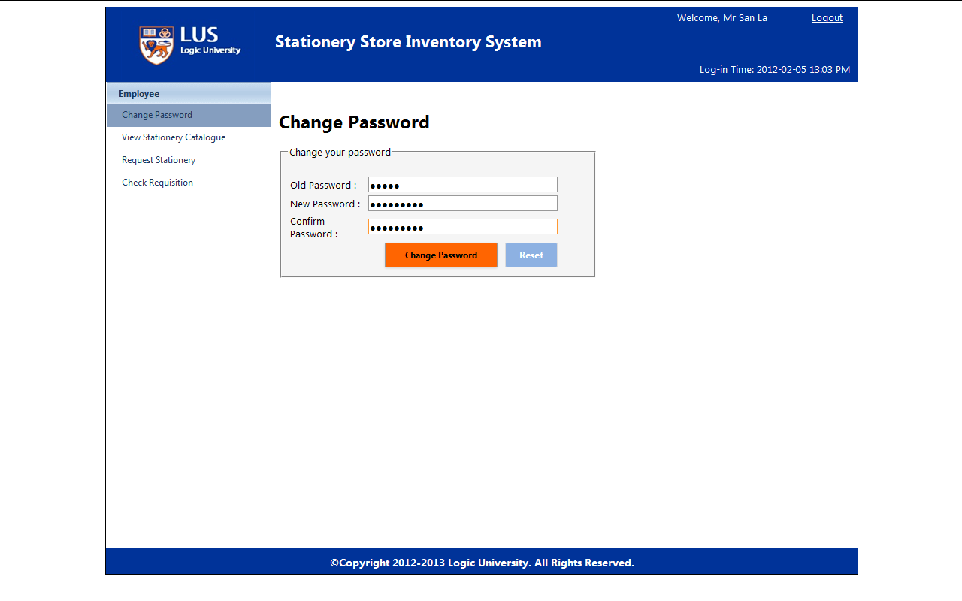

If old password is wrong, screen will be show like this.

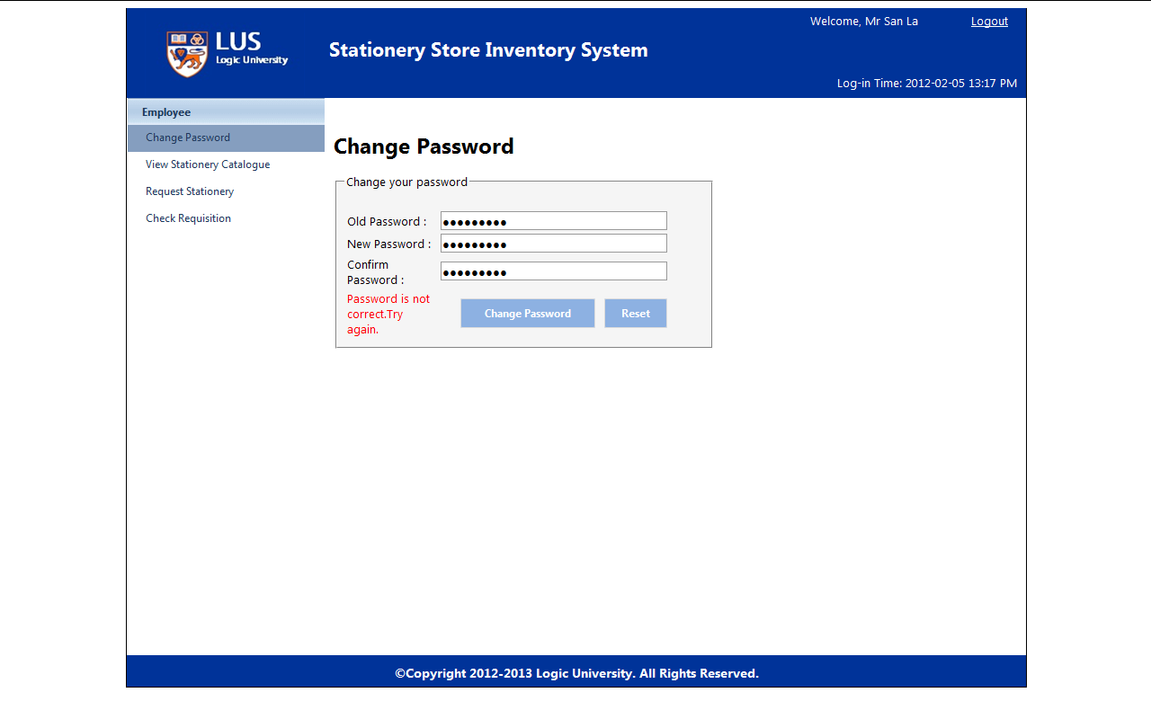

If new password and confirm password is not same, screen will be show like this.

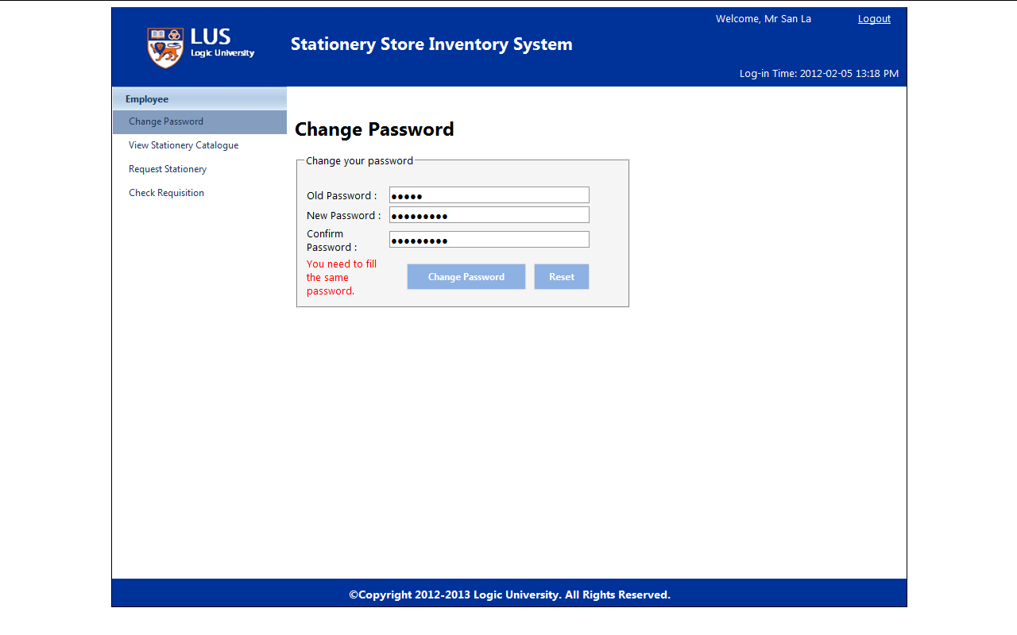

If employee wants to input password again, click “Reset”.

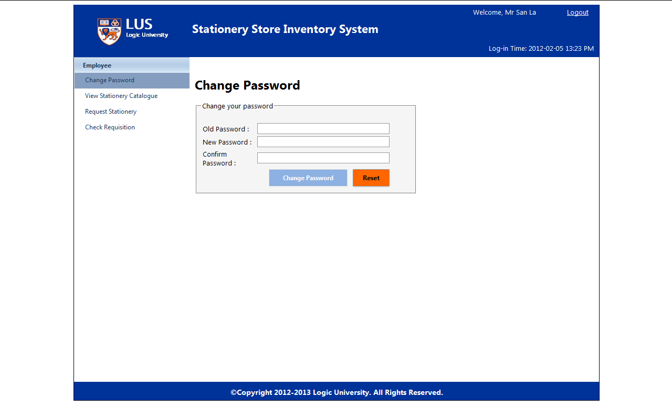

View Stationery Catalogue

If employee wants to view stationery catalogue, click “View Stationery Catalogue” link from menu.

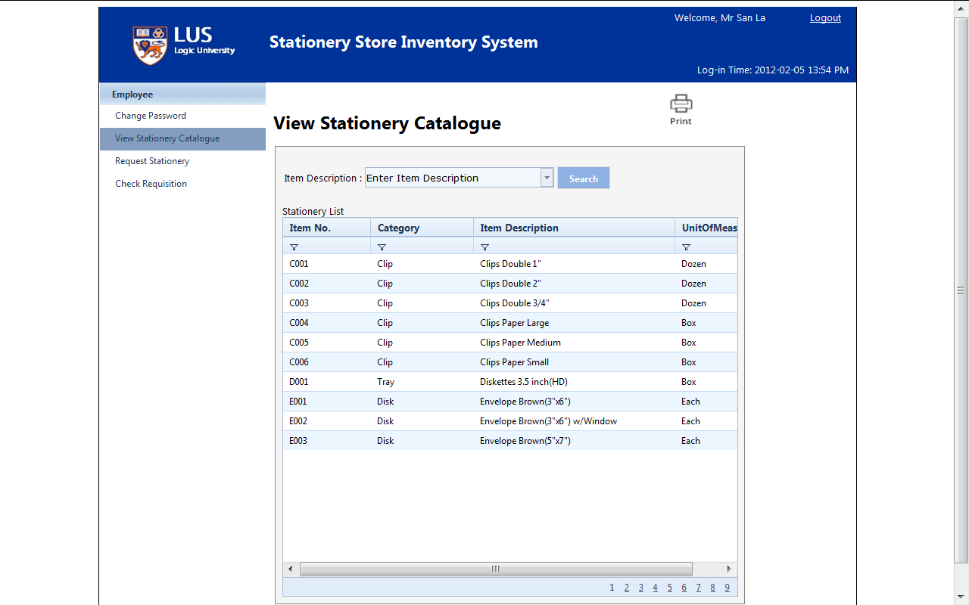

Input item description key name and click “Search”, can see a list of item details.

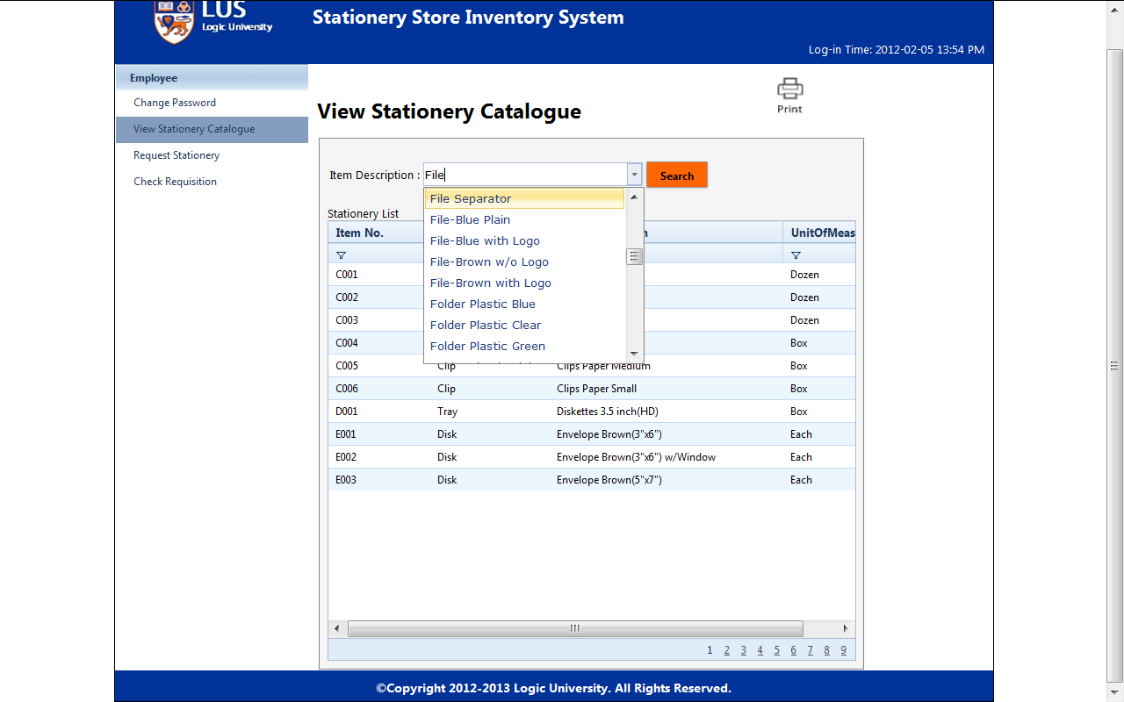

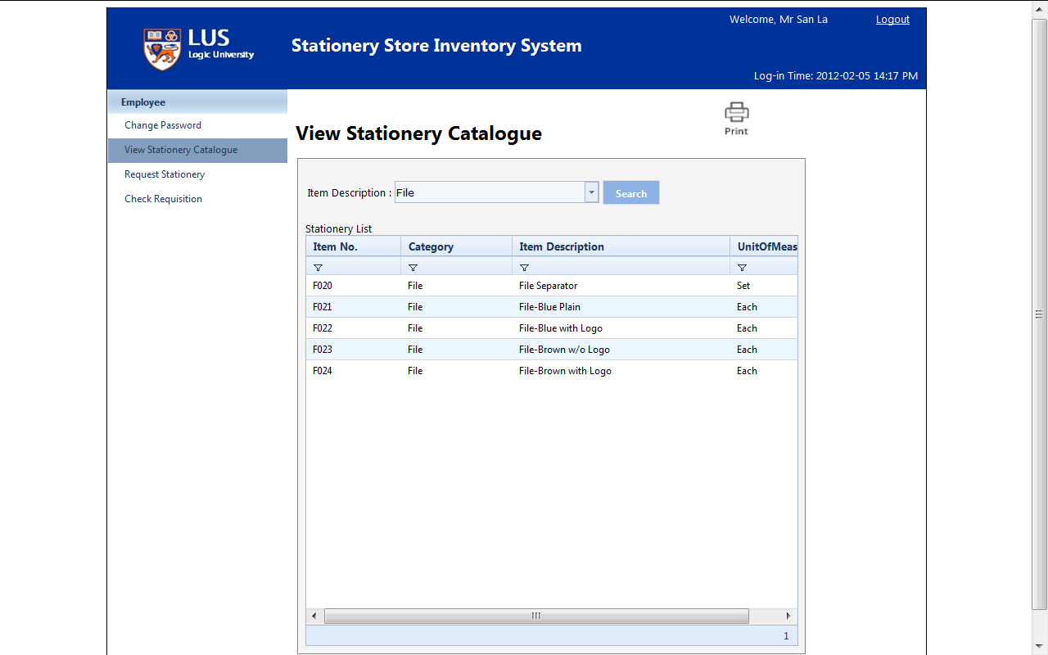

Request Stationery

If employee wants to request stationery, clicks ” Request Stationery” link from menu.

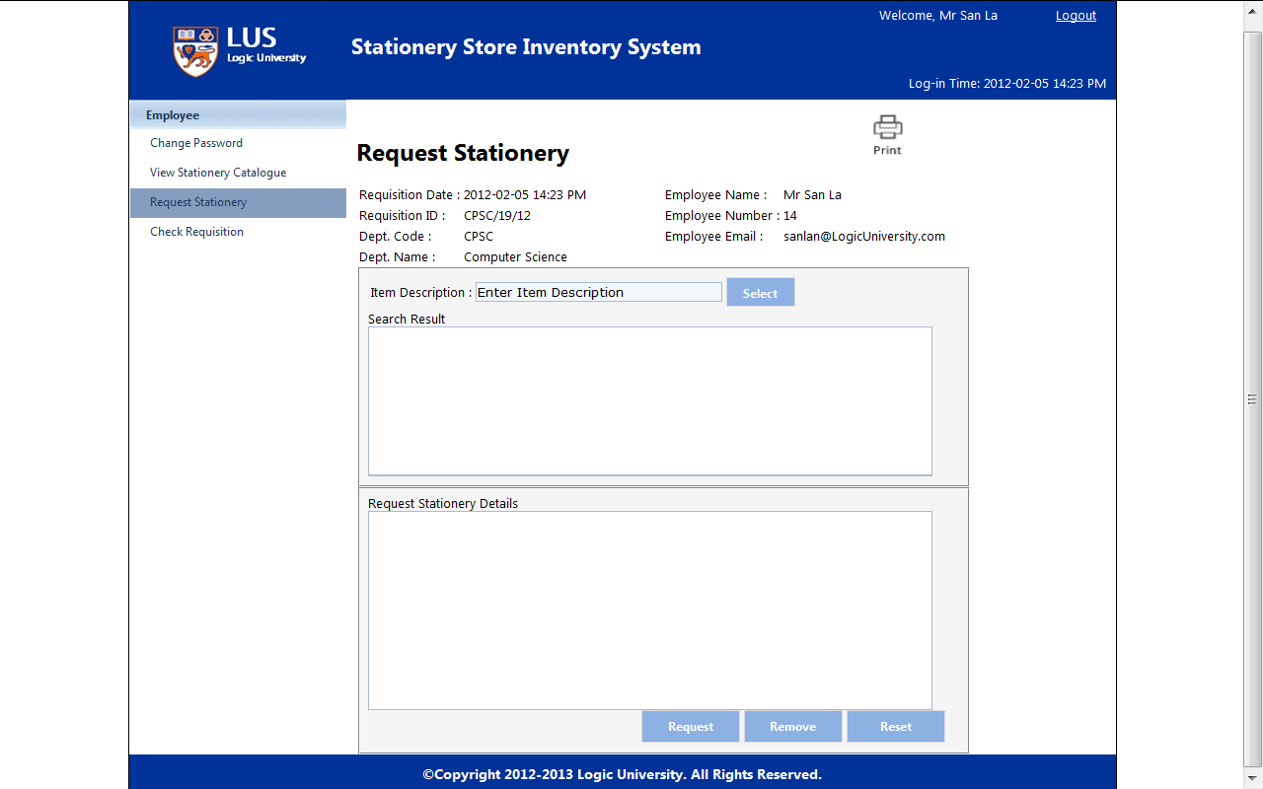

Input item description key and click “Select”

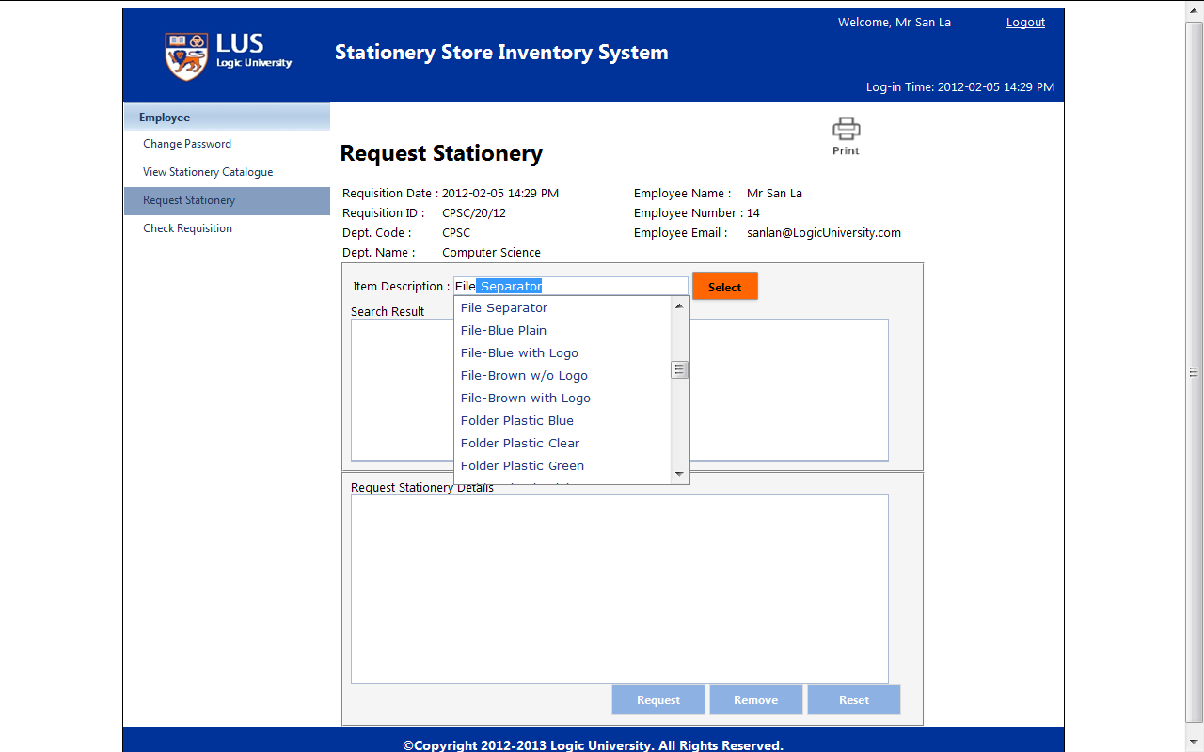

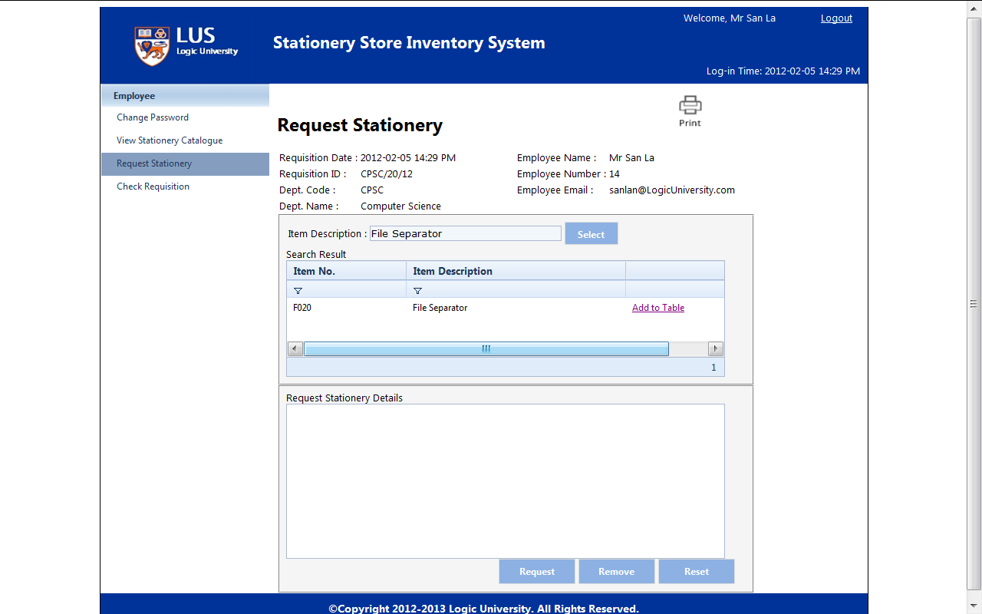

After search and confirm the item correct, Click “Add to Table” to add this item into requisition stationery. After adding, “Required Qty” can be modified.

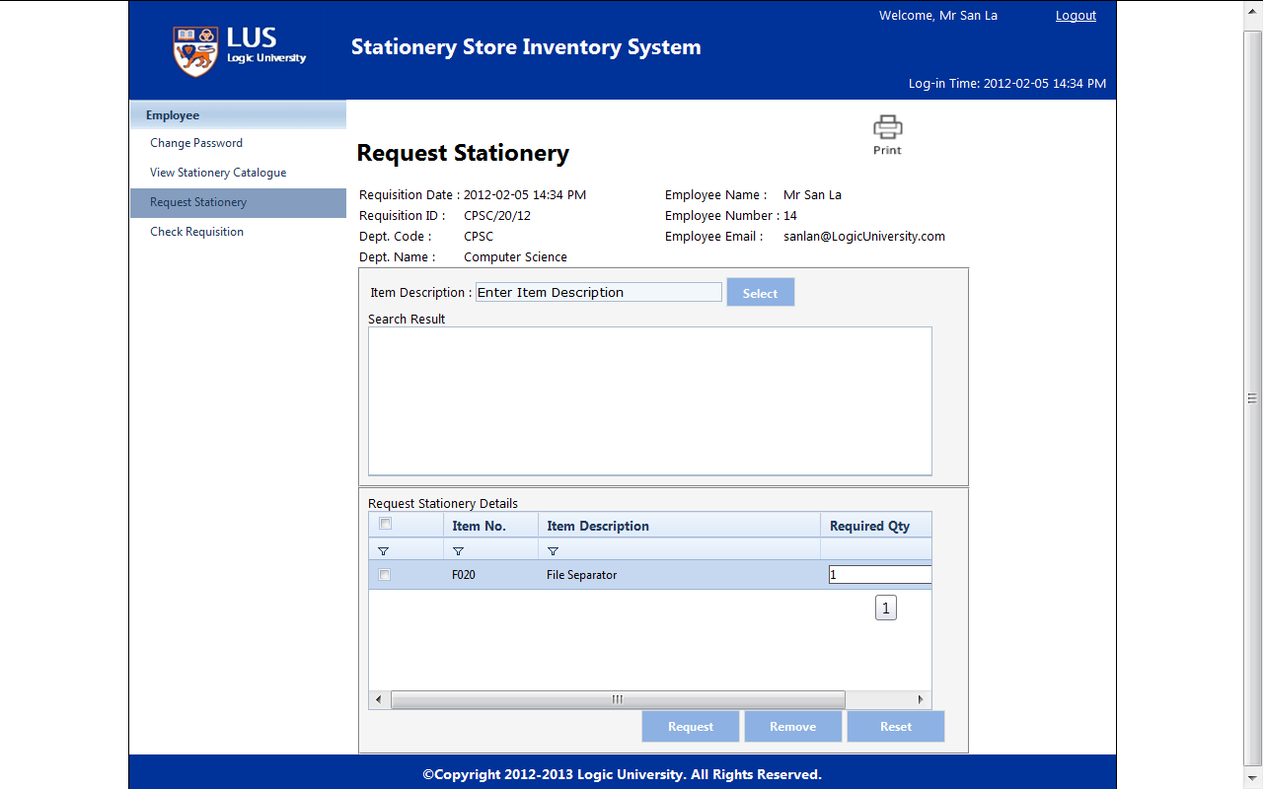

Select the item and click ”Request”, system will send the requisition to department head for approve automatically.

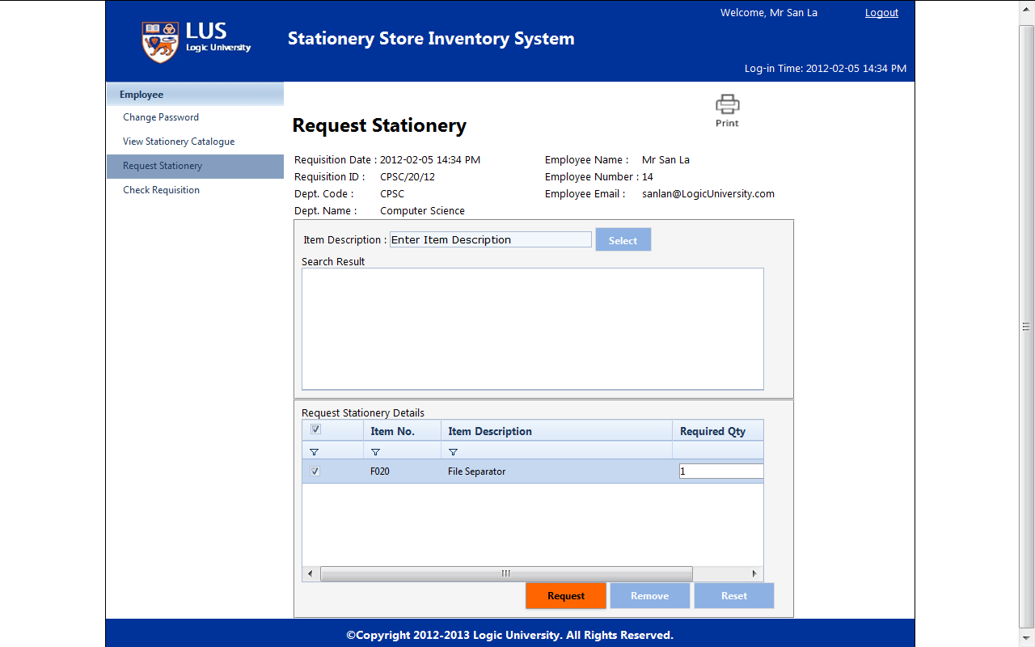

At the same time, direct to check requisition screen.

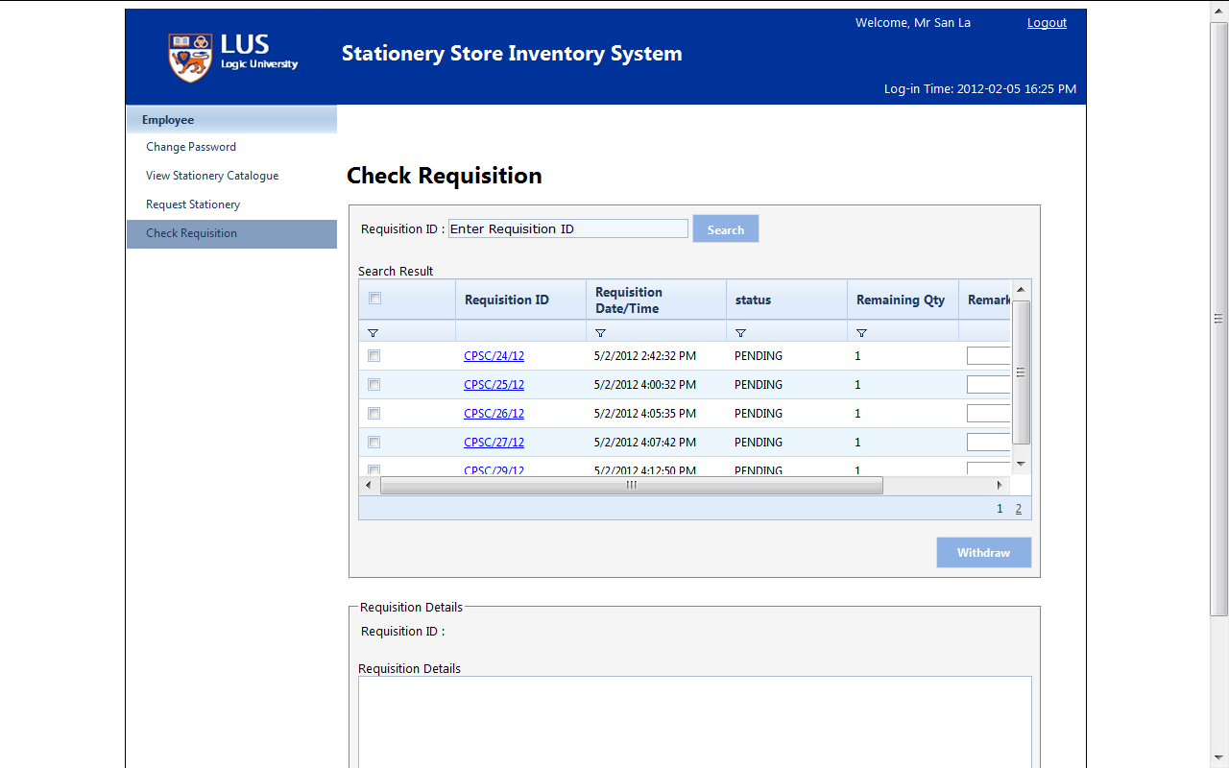

Select the item and click ”Remove”, system will automatically remove the requisition.

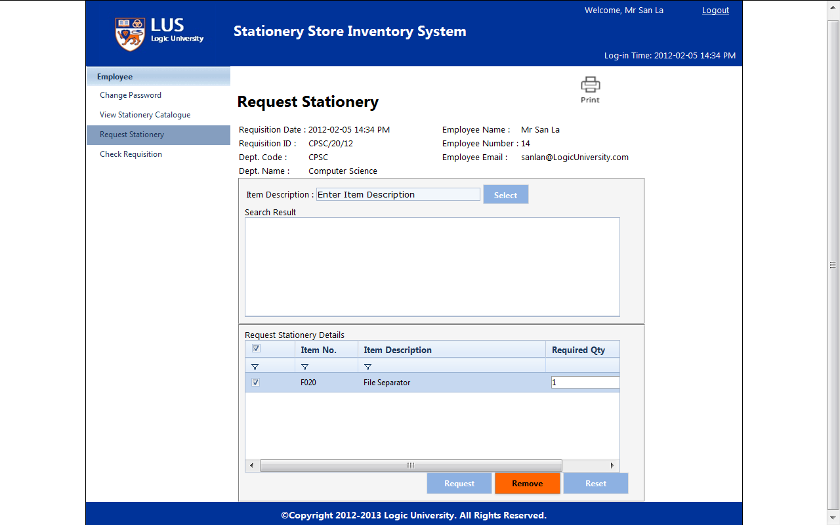

Select the item and click ”Reset”, system will automatically clear.

(Screen)

Check Requisition

Input requisition id and click ”Search” .

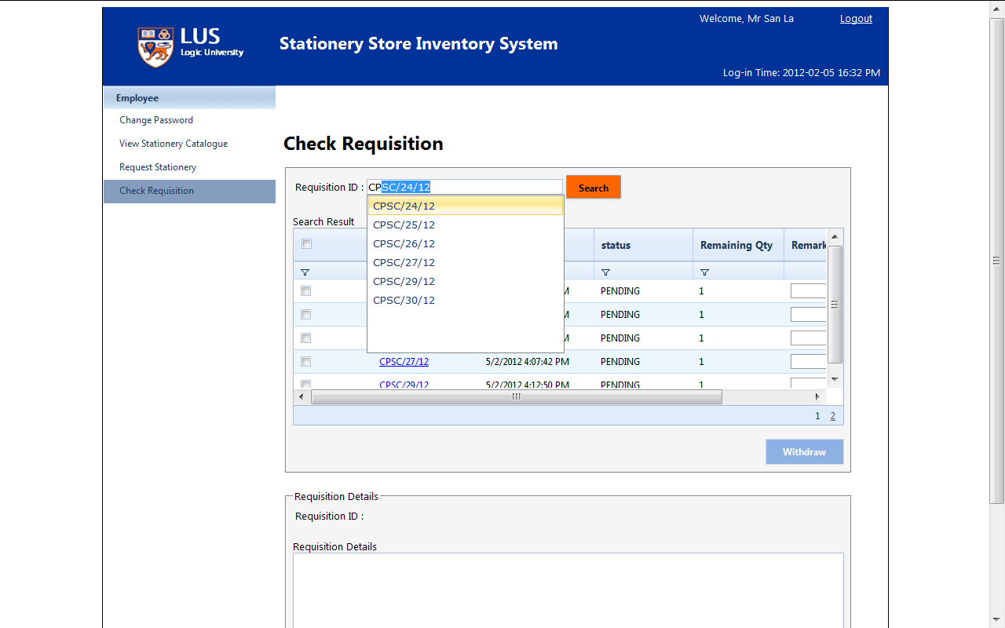

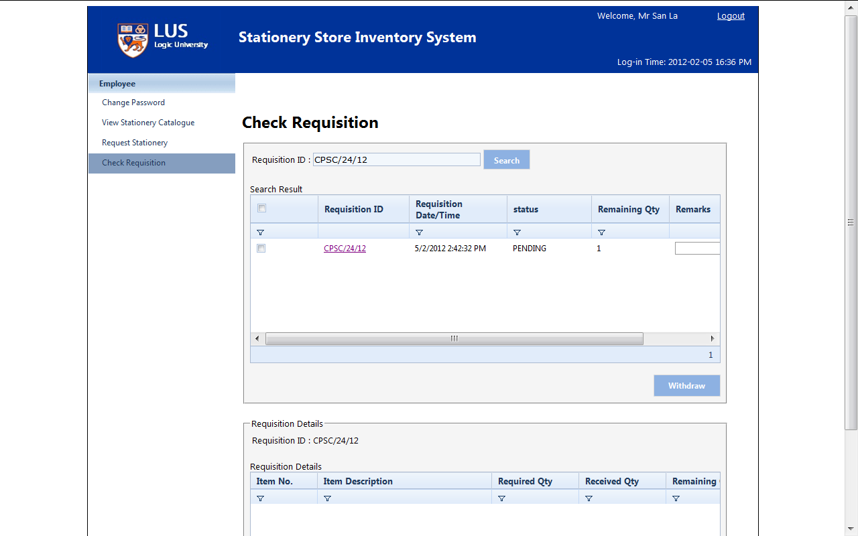

Click requisition id and see the requisition detail

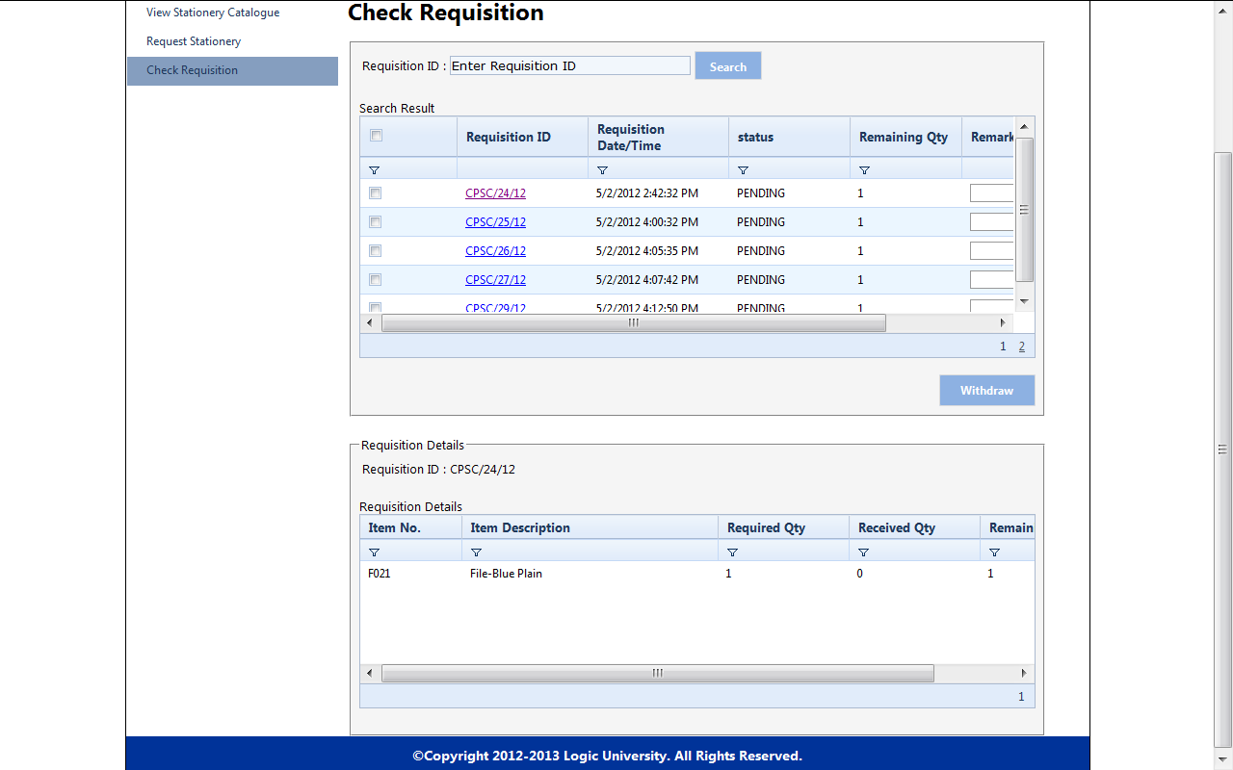

Select requisition id and click “Withdraw”

(Screen)

Head: